**Name : Aarya Tiwari**

**Batch : B2:**

**Roll No. : 16010421119**

**Course: Web Programming II**

**Experiment No. : 4**

**Code:**

<?php

    $cookie_name = "user1";

    $cookie_value = "Aarya Tiwari was here";

    function makeCookie($name, $value, $expire, $path)

    {

        setcookie($name, $value, time() + ($expire), "/");

    }

?>

<html>

    <head>

        <link rel="stylesheet" href="style.css">

    </head>

<body>

    <button type="button" id="startButton" onclick="<?php makeCookie("user1","Aarya Tiwari was here",2,"/")?>">

        Set Cookie

    </button>

    <div id="countdown"></div>

    <script src="script.js"></script>

<?php

    if(!isset($_COOKIE["user1"])) {

        echo "Cookie named " . $cookie_name . " is not set!";

    } else {

        echo "Cookie " . $cookie_name . " is set!<br>";

        echo "Value is: " . $_COOKIE[$cookie_name];

    }

?>

</body>

</html>

body {

    display: flex;

    flex-direction: column;

    align-items: center;

    justify-content: center;

    height: 100vh;

    margin: 0;

    font-family: Arial, sans-serif;

  } */

  #countdown {

    font-size: 24px;

    margin-top: 20px;

  }

document.getElementById("startButton").addEventListener("click", startCountdown);

function startCountdown() {

    const countdownElement = document.getElementById("countdown");

    let remainingTime = 20; *// in seconds*

    const countdownInterval = setInterval(() => {

        countdownElement.textContent = `Time remaining: ${remainingTime} seconds`;

        remainingTime--;

*// if (remainingTime < 0) {*

*//   clearInterval(countdownInterval);*

*//   countdownElement.textContent = "Countdown expired!";*

*// }*

    }, 1000);

}

**Output:**

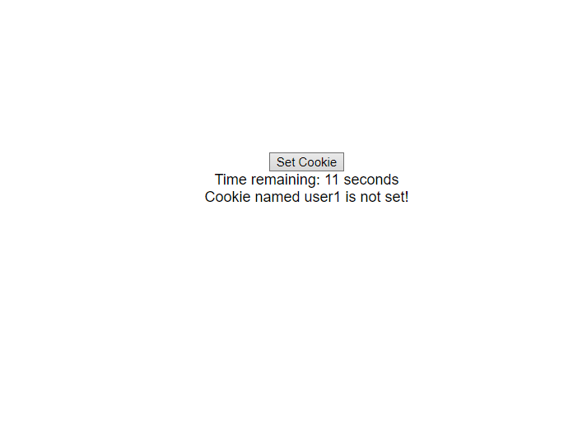

**Outcomes:**

CO2: Design forms and use session handling mechanism with web applications

**Conclusion:**

**We can conclude we have learnt about sessions and cookies.**